**CYBER FORZA**

A reference document used to install Nagios on Unbuntu

Revision: Draft specification1.0

July 2017

**Cyber Forza Inc. Confidential and Proprietary**

Copyright © 2017, Cyber Forza Incorporation. All rights reserved.

This document contains information that is considered proprietary and the property of Cyber Forza Inc. The content of this document may not be used in any way, duplicated, or distributed by any means without the express written permission of Cyber Forza Inc

Unless otherwise agreed in writing, by Cyber Forza Inc., The Cyber Forza products are not designed or intended for any application in which the failure of the product could create a situation where personal injury or death may occur.

Cyber Forza Inc. may change specifications and product description at any time, without notice.

Contact Cyber Forza Inc. to obtain latest specification.

# Contents

1 Revision History …………….………………………………………………….…..….4

2Quick Start Guide ……………………………………………………….……….…..…5

2.1 System Specification..………………………………..….………………………...... 5

2.2 Support Information……………………………………....……………………….…5

2.3 Getting Started.…………………………………………….…………………….….. 5

2.4 Requirements………………………………………………………………….….…..6

2.5 Installing Nagios and plugins…………………………………………………......….6

3 Apache web server Configuration for Nagios3..…………………………………..…...8

# Revision History

|  |  |  |
| --- | --- | --- |
| Date | Revision No. | Description |
| 12/07/17 | Draft Release 1.0 | Initial version |
|  |  |  |

# 2Quick Start Guide

# 2.1 System Specification

*Table 1: System Configuration*

|  |
| --- |
| * Ubuntu 16.04.1 LTS (Linux Kernel 4.4) |
| * System RAM: 3911776 KB |
| * Hard Disk space: 21.1 GB |
| * OS type: 64-bit |
| * Memory: 3.7 GiB |
| * Processor: Intel Core 2 Duo CPU E8400 @ 3.00GHz x 2 |

# 2.2 Support Information

* Please contact the Cyber Forza Inc. team for support

# 2.3 Getting Started

**Nagios** is a powerful monitoring system computer-software application that monitors systems, networks and infrastructure.

Nagios offers monitoring and alerting services for servers, switches, applications and services

Nagios sends alerts when critical infrastructure components fail and recover, providing administrators with notice of important events.

# 2.4 Requirements

First make sure that all your system packages are up-to-date by running these following apt-get commands in the terminal.

*sudo apt-get update*

*sudo apt-get upgrade*

A Ubuntu 16.04 LAMP server is required.

Install LAMP (Linux, Apache, MariaDB, PHP) server.

*apt-get install php7.0 openssl perl make php7.0-gd libgd2-xpm-dev libapache2-mod-php7.0 libperl-dev libssl-dev daemon wget apache2-utils unzip*

Create users and groups for Nagios.

Now create a new nagios user account and setup a password to this account:

useradd nagios groupadd nagcmd usermod -a -G nagcmd nagios usermod -a -G nagcmd www-data

*useradd nagios*

*groupadd nagcmd*

*usermod -a -G nagcmd nagios*

*usermod -a -G nagcmd www-data*

# 2.5 Installing Nagios and plugins

First thing to do is to go to Nagios’s download page and download the latest stable version of Nagios, At the moment of writing this article it is version 4.1.1:

wget  https://assets.nagios.com/downloads/nagioscore/releases/nagios-4.1.1.tar.gz

tar -zxvf nagios-4.1.1.tar.gz

***NOTE** If you install from the package cf.monitoring.utilities.1-0.deb then go to /usr/cf.monitoring and follow the instructions:***

cd nagios-4.1.1/

Perform below steps to compile the Nagios from the source code:

*./configure --with-nagios-group=nagios --with-command-group=nagcmd --with-httpd_conf=/etc/apache2/sites-enabled/*

*make all*

*make install*

*make install-init*

*make install-config*

*make install-commandmode*

*make install-webconf*

Next steps, Download latest nagios-plugins source and install using following commands:

*wget http://www.nagios-plugins.org/download/nagios-plugins-2.1.1.tar.gz*

*tar xzf nagios-plugins-2.1.1.tar.gz*

***NOTE** If you install from the package cf.monitoring.utilities.1-0.deb then go to /usr/cf.monitoring and follow the instructions:***

*cd nagios-plugins-2.1.1*

*./configure --with-nagios-user=nagios --with-nagios-group=nagios*

*make*

*make install*

Edit *the /usr/local/nagios/etc/objects/contacts.cfg config* file with your favorite editor and change the email address associated with the nagiosadmin contact definition to the address you’d like to use for receiving alerts.

*nano /usr/local/nagios/etc/objects/contacts.cfg*

Change the email address field to receive the notification:

[...]

*define contact{*

*contact_name nagiosadmin ; Short name of userus*

*generic-contact ; Inherit default values from generic-contact template (defined above)*

*alias Nagios Admin ; Full name of useremail*

*admin@hostA.net* ; <<***** CHANGE THIS TO YOUR EMAIL ADDRESS ******

# 3 Apache web server Configuration for Nagios

Now create Nagios apache2 configuration file:

*nano /etc/apache2/sites-enabled/nagios.conf*

|  |
| --- |
|  |

Edit the following lines if you want to access Nagios administrative console from a particular IP series, Here, I want to allow Nagios administrative access from 192.168.50.0/24 series only:

[...]

*## Comment the following lines ##*

*#   Order allow,deny*

*#   Allow from all*

*## Uncomment and Change lines as shown below ##*

*Order deny,allow*

*Deny from all*

*Allow from 127.0.0.1 192.168.50.0/24*

*[...]*

Enable Apache’s rewrite and cgi modules:

*sudo a2enmod rewrite*

*sudo a2enmod cgi*

We need to setup the password for the user nagiosadmin. This username will be used to access the web interface so it is important to remember the password that you will input here.

*# sudo htpasswd -s -c /usr/local/nagios/etc/htpasswd.users nagiosadmin*

*New password:*

*Re-type new password:*

*Adding password for user nagiosadmin*

Restart Apache for the changes to take effect:

*systemctl restart apache2*

|  |
| --- |
|  |

|  |
| --- |
|  |

Next we have to make Nagios start at boot time, so first verify that the configuration file has no errors running the following command:

*sudo /usr/local/nagios/bin/nagios -v /usr/local/nagios/etc/nagios.cfg*

Ubuntu 16.04 uses systemd for starting / stopping all the services, so, we need to create nagios.service file:

*nano /etc/systemd/system/nagios.service*

|  |  |
| --- | --- |
|  |  |

Add the following lines:

*[Unit]*

*Description=Nagios*

*BindTo=network.target*

*[Install]*

*WantedBy=multi-user.target*

*[Service]*

*User=nagios*

*Group=nagios*

*Type=simple*

*ExecStart=/usr/local/nagios/bin/nagios /usr/local/nagios/etc/nagios.cfg*

Enable Nagios to start automatically at system startup:

*systemctl enable /etc/systemd/system/nagios.service*

Now, start Nagios service:

*systemctl start nagios*

|  |  |
| --- | --- |
|  |  |

To review in details each configuration options, please refer to : <https://www.nagios.org/>

Nagios will be available on HTTP port 80 by default. Open a browser and navigate to http://yourdomain.com/install.php or http://server-ip/install.php and complete the required the steps to finish the installation. When prompted for username and password you will introduce the username “nagiosadmin” and the password that you entered previously.

***\*\*\* NOTE: Please review the file README from the package cf.monitoring.utilities.1-0.deb, to verify which files and/or configurations files should be replaced.***

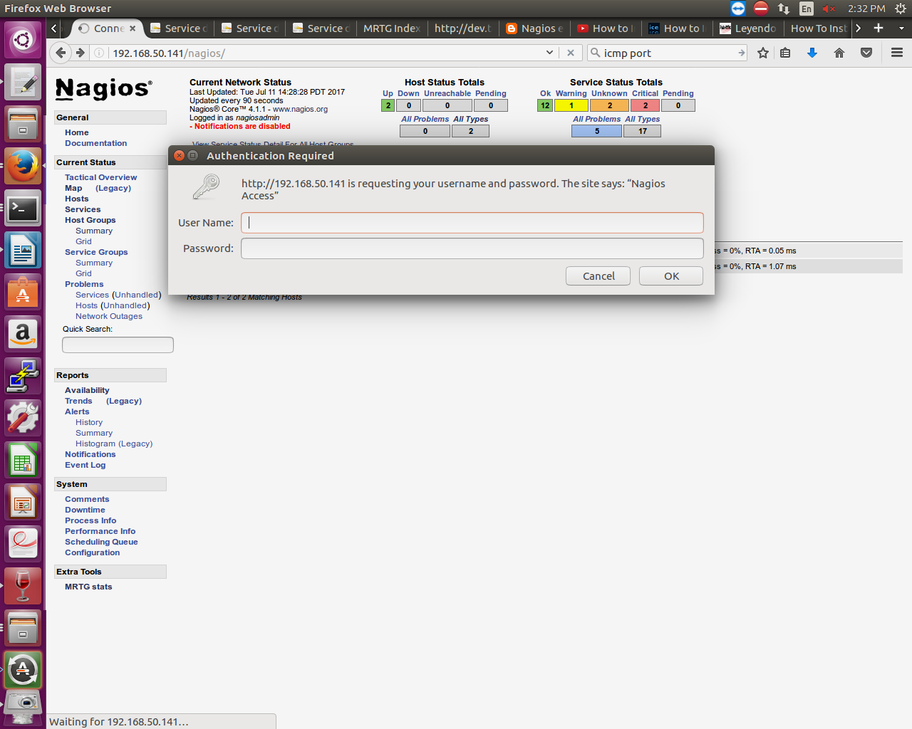

Figure1: Nagios prompted for username and password

After we provide the right credentials, we should see the following interface:

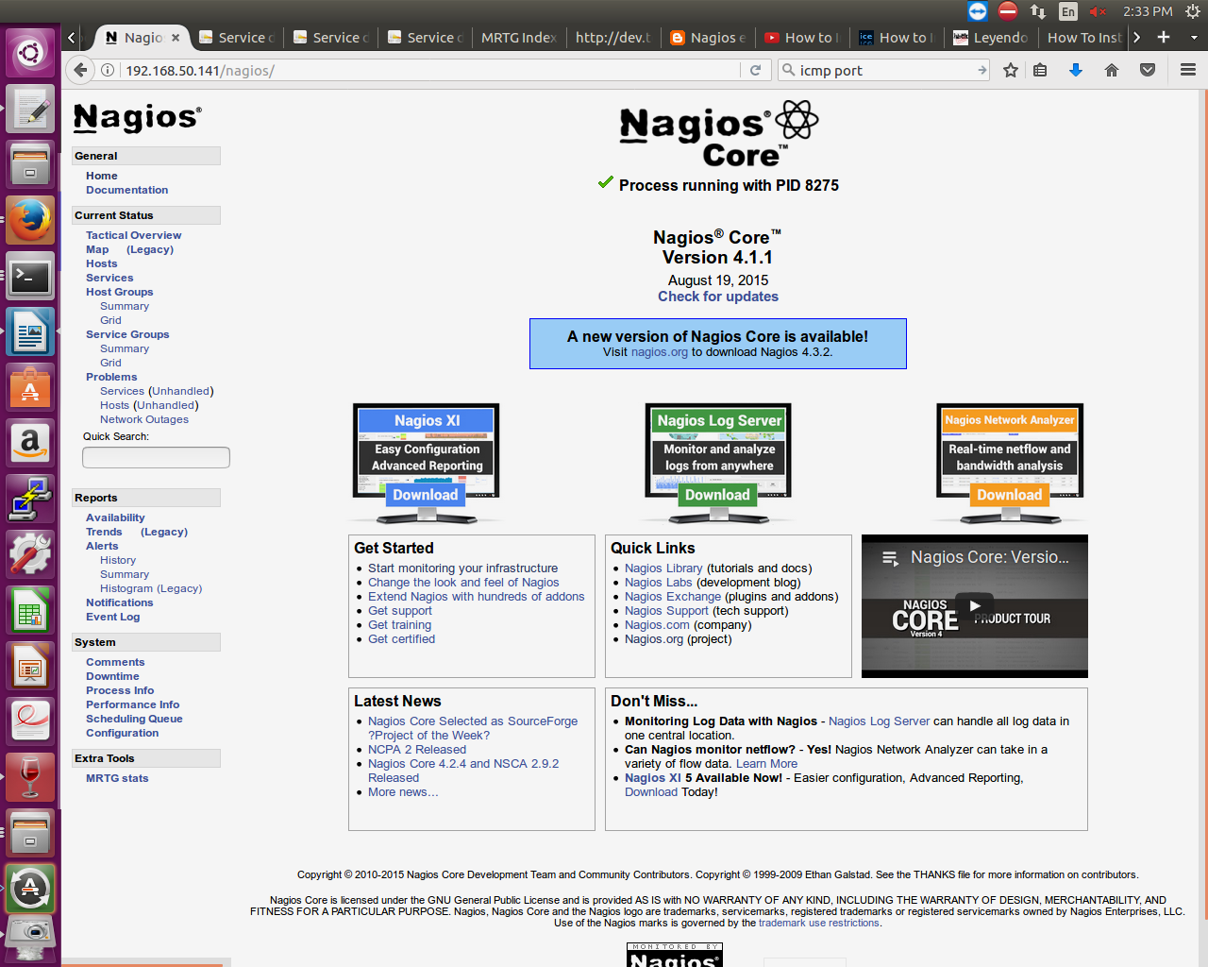

Figure2: Nagios Web insterface